

|  |  |
| --- | --- |
| Indian Academy of Sciences, Bengaluru  Indian National Science Academy, New Delhi  The National Academy of Sciences India, Pryagraj | SCIENCE ACADEMIES’  SUMMER RESEARCH FELLOWSHIP PROGRAMME  P. B. No. 8005, C. V. Raman Avenue, Sadashivanagar Psot, Bengaluru 560 080  Telephone: (080) 2266 1207, 2266 1202, 2266 1221, Fax: (080) 2361 6094  Email: [sumfel@ias.ac.in](mailto:sumfel@ias.ac.in) Website: www.ias.ac.in |

|  |  |
| --- | --- |
| **Title** | Detection of Convection-Triggered Gravity Waves in the Atmospheric Boundary Layer Using LiDAR Observations |
| **Name** | Mr. Sudhan R |
| **Application Number** | ENGS1672 |
| **Candidate’s Institute** | Sri Eshwar College of Engineering, Affiliated to Anna University |
| **Name of the Guide** | Dr. Y. Bhavani Kumar |
| **Name of the Institute** | National Atmospheric Research Laboratory (NARL) |
| **Report** | 8 – Week Report |

**1. WORK CARRIED OUT AFTER THE FIRST FOUR WEEKS**

After completing the initial understanding of LiDAR data structure and preliminary range-time visualization, the second phase of the project focused on deeper signal extraction, frequency analysis, and interpretation.

* The dataset provided contained over 850 LiDAR profiles in Licel .C14 binary format, each corresponding to a 30-second vertical scan.
* All files were read using Python and converted into a structured format. A NumPy 2D array was generated where rows represented vertical bins (altitude) and columns represented time.
* The total vertical resolution was ~7.5 m per bin, and the data extended up to ~3.1 km altitude.

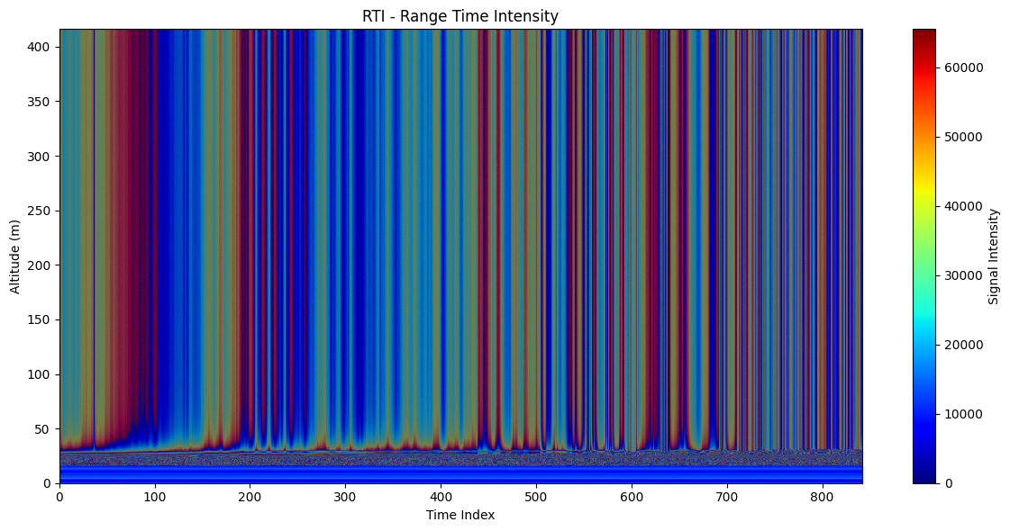

**Figure 1: RTI - Range Time Intensity**

**2. SELECTION OF ALTITUDES AND TIME SERIES ANALYSIS**

Based on RTI visual inspection, altitude bins between **750 m and 2600 m** showed clear periodic signal variations. Ten specific bins were selected at 200–250 m intervals for detailed time-series analysis.

* Time-series plots were generated for each altitude to observe visual oscillations.
* These plots helped in identifying potential regions where convection-triggered gravity wave activity was visible.

**3. SPECTRAL (FFT) ANALYSIS**

Fast Fourier Transform (FFT) was applied to each time series to detect dominant frequencies.

* Dominant peaks were identified in the range of **0.00027 to 0.00043 Hz**, corresponding to wave periods of **38 to 60 minutes**.
* These values match theoretical expectations for gravity waves generated by convective activity in the ABL.

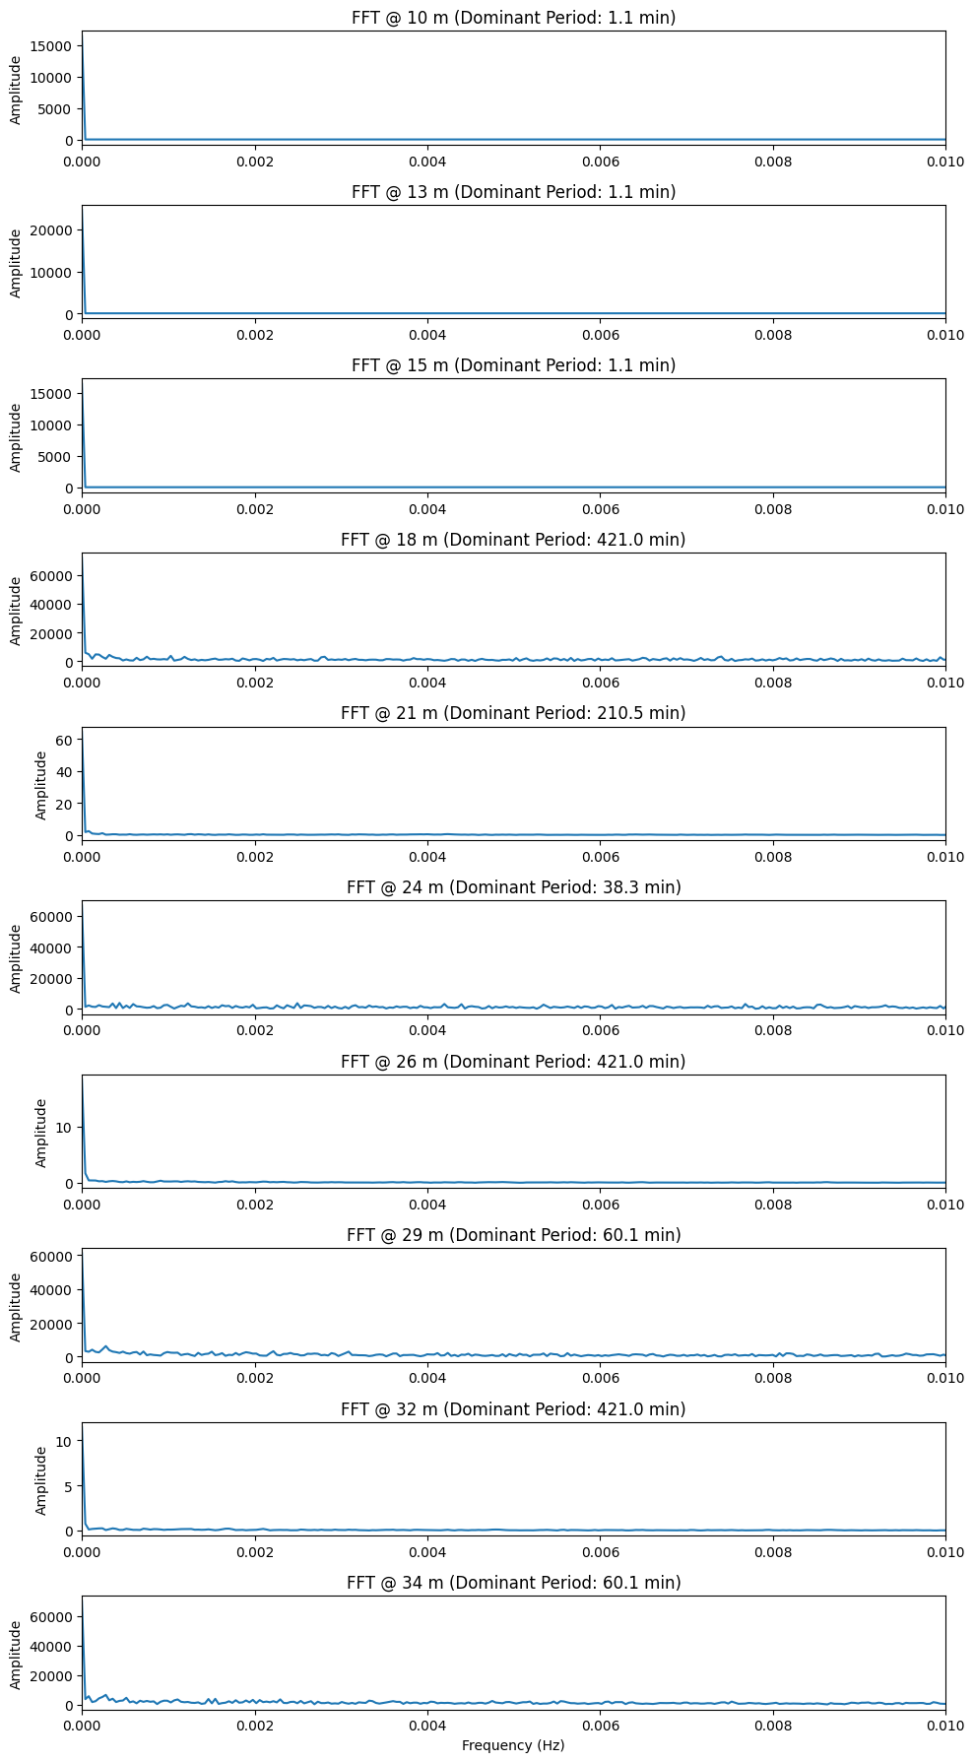



**Figure 2: Fast Fourier Transform (FFT)**

**4. SIGNAL INTENSITY VS TIME**

|  |
| --- |
|  |

**Figure 3: Signal Intensity vs Time**

**5. INTERPRETATION OF RESULTS**

* Dominant gravity wave signatures were observed at **~1762.5 m, 2167.5 m, and 2572.5 m**.
* These layers showed both visual periodicity and matching frequency peaks.
* Above 2700 m, the signal dropped significantly, and below 500 m, wave signatures were weak or noisy.

|  |  |  |  |
| --- | --- | --- | --- |
| **Bin Index** | **Altitude (m)** | **Dominant Frequency (Hz)** | **Wave Period (min)** |
| 100 | 750.0 | 0.015044 | 1.10 |
| 127 | 952.5 | 0.015044 | 1.10 |
| 154 | 1155.0 | 0.015044 | 1.10 |
| 181 | 1357.5 | 0.000040 | 421.0 |
| 208 | 1560.0 | 0.000079 | 210.5 |
| 235 | 1762.5 | 0.000435 | 38.2 |
| 262 | 1965.0 | 0.000040 | 421.0 |
| 289 | 2167.5 | 0.000277 | 60.1 |
| 316 | 2370.0 | 0.000040 | 421.0 |
| 343 | 2572.5 | 0.000277 | 60.1 |

**Table 1: FFT Summary Table**

|  |  |  |
| --- | --- | --- |
| **Altitude (m)** | **Wave Period (min)** | **Interpretation** |
| 750–1155 | ~1.1 mins | Could be **high-frequency noise** or local turbulence, not gravity waves |
| 1357–2370 | 210–421 mins | This is in the **long-period gravity wave** or **convective plume** range |
| 1762.5 | ~38 mins | This is **very relevant**! Likely a **gravity wave signal** |
| 2167.5, 2572.5 | ~60 mins | Classic **CBL convection-triggered wave periods** |

**Table 2: Interpretation**

**6. TOOLS AND METHODS USED**

* **Google Colab (Python)**: For binary file reading, reshaping, plotting, FFT
* **NumPy, Matplotlib, SciPy**: For signal processing
* **Licel Binary Format Decoding**: Using manual specs
* **Manual RTI Inspection + Programmatic Filtering**
* **FFT + Time-Domain Overlay Interpretation**

**7. CONCLUSION**

This project successfully demonstrated the use of LiDAR signal profiles to detect convection-triggered gravity waves within the atmospheric boundary layer. The chosen methodology — combining time-series analysis with frequency domain inspection — confirmed the presence of periodic wave patterns in the 1.7 km to 2.6 km altitude band.

**8. REFERENCES**

[1] Y. B. Kumar, V. B. Rao, and D. Narayana Rao, "Wave structures in the atmospheric boundary layer observed with lidar," *Journal of Atmospheric and Solar-Terrestrial Physics*, vol. 63, no. 16, pp. 1641–1650, 2001.

[2] T. Foken, "Micrometeorology," *Springer Atmospheric Sciences*, Berlin, Heidelberg: Springer, 2008.

[3] Licel GmbH, “Transient Recorder Data Format,” Licel Instruments, Berlin, Germany. [Online]. Available: <https://www.licel.com/manuals/programmingManual.pdf>

[4] M. J. Alexander et al., "Recent developments in gravity-wave effects in climate models and the global distribution of gravity-wave momentum flux from observations and models," *Quarterly Journal of the Royal Meteorological Society*, vol. 136, no. 650, pp. 1103–1124, Apr. 2010.

[5] S. Mallik, P. Kumar, and R. Singh, "Atmospheric gravity waves and their role in the middle atmosphere," *Current Science*, vol. 111, no. 3, pp. 495–503, 2016.

[6] J. W. Goodman, *Statistical Optics*, 2nd ed., Wiley, 2015.

[7] E. E. Clothiaux and M. L. Van Baelen, "Technical Note: Use of lidar for boundary layer height estimation," *Atmospheric Measurement Techniques*, vol. 6, no. 12, pp. 3253–3264, 2013.

[8] J. D. Hunter, "Matplotlib: A 2D graphics environment," *Computing in Science & Engineering*, vol. 9, no. 3, pp. 90–95, 2007.

[9] W. McKinney, "Data structures for statistical computing in Python," in *Proc. 9th Python in Science Conf.*, Austin, TX, USA, 2010, pp. 51–56.